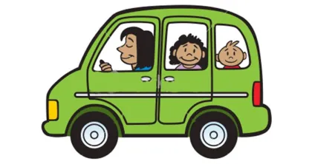
Elementary Car Line
AM DROP OFF 7:45 AM- 8:05 AM
- Enter the WEST ENTRANCE into the parking lot from Chicory. Form a single line!
- Staff will open car doors to let out students.
- ALL students are required to be dropped off via the car line, parents will NOT be allowed to park and walk their children across as this is a safety issue and slows down the drop off procedure.
- Late (after 8:05 AM) students will need to be walked into the front entryway to be SIGNED IN PRIOR to entering the building.
PM PICK UP line up begins no earlier than 2:45 PM
- Enter the EAST EXIT into the parking lot from Chicory. Prior to 2:45 PM, wait to enter the parking lot until a STAFF MEMBER WAVES you in!!
- We are snaking through the parking lot (follow the cones).
  - Once around the first corner, you will form 2 lines as directed.
  - There WILL be a line of cars waiting to come into the parking lot on Chicory.
  - DO NOT SKIP the line!!
  - PLEASE DO NOT BLOCK THE WEST DRIVEWAY ENTRANCE FROM THE STREET!!
- Please display your CARLINE folder on your dash or visor so staff can see it to place students in the correct dismissal order and car.
- Once dismissal starts at 3:20, we will be done in 20-25 minutes. PLEASE be patient!
- ALL students will be dismissed through the car line for their safety and car line efficiency. Walkups will be directed back to their cars to get into carline.
Elementary: Dismissal is at 3:20 PM
Late pick up charge begins at 3:50 PM
Etiquette
- NO SMOKING/VAPING ON SCHOOL PROPERTY (EVEN WHILE IN YOUR CAR)
- DO NOT PASS OTHER CARS IN CAR LINE UNLESS DIRECTED BY A STAFF MEMBER AT PICK UP OR DROP OFF
- REMEMBER TO BE AWARE OF STREET & LOT TRAFFIC WHEN ENTERING & EXITING THE PARKING LOT
- NO FOUL LANGUAGE/GESTURES TO STAFF OR OTHER DRIVERS
PLEASE LET ALL PICKUP PEOPLE KNOW THESE EXPECTATIONS OF CAR LINE ETIQUETTE

